Practical No. 5
Study and implementation of Express.js

Problem Statement 1: Database Connectivity using SQL / Oracle
- Connect to Database and Retrieve Data
Answer:
• Node.js uses libraries like mysql2 or oracledb to connect to databases
• It allows executing SQL queries and retrieving results
Example:
const mysql = require('mysql2');
const db = mysql.createConnection({
host: 'localhost',
user: 'root',
password: '',
database: 'test'
});
db.connect((err) => {
if (err) {
console.log("Connection error");
return;
}
db.query("SELECT * FROM users", (err, result) => {
if (err) throw err;
console.log(result);
});
});
Key Points:
• createConnection() → establishes connection
• query() → executes SQL query
• Result is returned as array of objects

Problem Statement 2: Middleware (Express.js)
- What is Middleware?
Answer:
• Middleware is a function that executes between request and response
• It can modify request or response objects
Uses:
• Logging
• Authentication
• Validation

- Custom Middleware
Answer:
const logger = (req, res, next) => {
console.log(req.url);
next();
};
app.use(logger);
Key Points:
• req → request object
• res → response object
• next() → passes control to next function

- Execution Order of Middleware
Answer:
• Middleware executes in the order it is defined
• Order of app.use() is important
Example:
• app.use(A)
• app.use(B)
Execution:
• A → B → Route Handler
• If next() is not called, request stops

Problem Statement 3: File System (fs Module)
- Read and Write Files
Answer:
const fs = require('fs');
fs.readFile('file.txt', 'utf8', (err, data) => {
console.log(data);
});
fs.writeFile('file.txt', 'Hello', () => {});

- Difference between readFile and readFileSync
Answer:
• readFile → asynchronous, non-blocking
• readFileSync → synchronous, blocking

- Check File Exists
Answer:
fs.existsSync('file.txt');

- Asynchronous File Handling
Answer:
• Uses callbacks, promises or async/await
• Does not block execution
• Improves performance

Problem Statement 4: File Upload and Download API
- Upload File
Answer:
const multer = require('multer');
const storage = multer.diskStorage({
destination: 'uploads/',
filename: (req, file, cb) => {
cb(null, Date.now() + '-' + file.originalname);
}
});
const upload = multer({
storage: storage,
limits: { fileSize: 10 * 1024 * 1024 }
});
app.post('/upload', upload.single('file'), (req, res) => {
res.send("File uploaded successfully");
});

- Download File
Answer:
app.get('/download/:name', (req, res) => {
const filePath = 'uploads/' + req.params.name;
res.download(filePath);
});

- Error Handling
Answer:
• Set file size limit using multer
• Validate file type (image, pdf, etc.)
• Handle errors using middleware or try-catch

- File Versioning
Answer:
• Prevents overwriting files with same name
• Use unique naming

Example:
• Date.now() + originalname
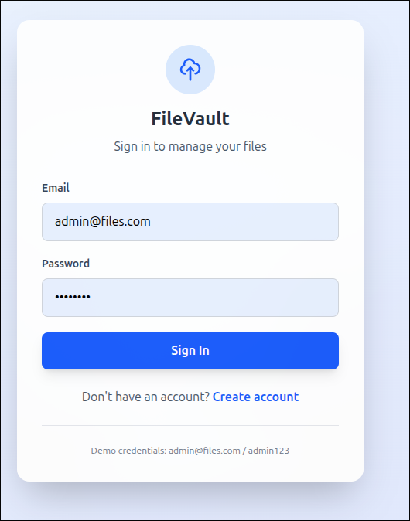
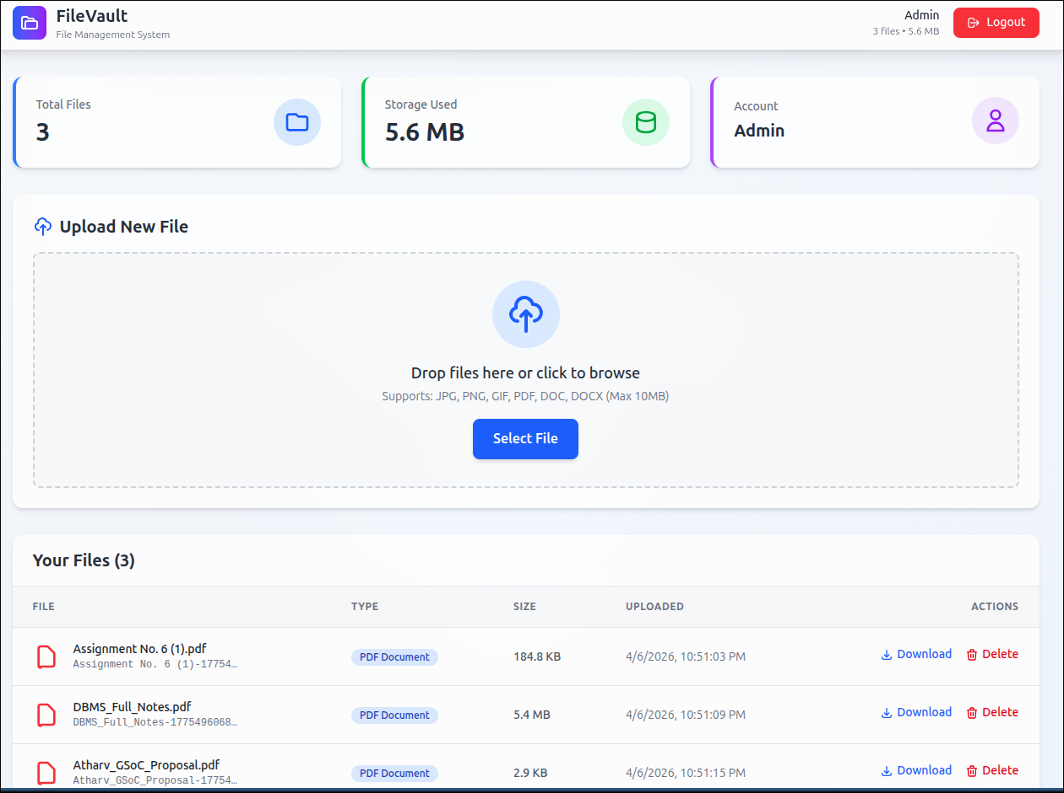
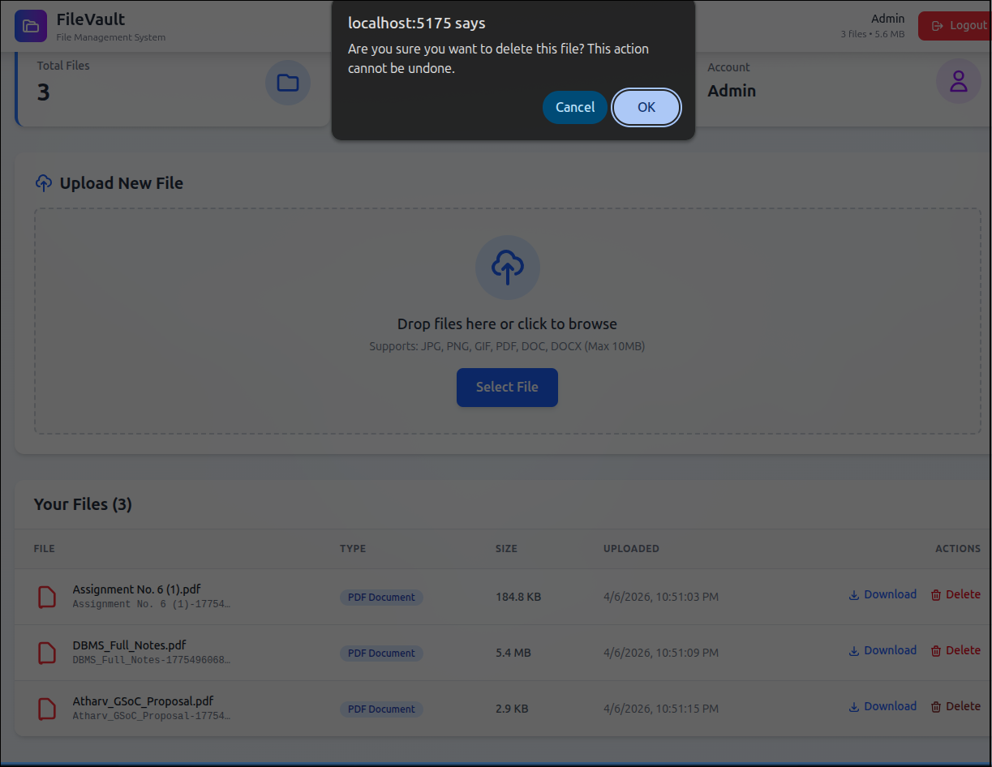

Problem Statement 5: Real-time Chat Application (Socket.io)
- Setup Server
Answer:
const express = require('express');
const http = require('http');
const { Server } = require('socket.io');
const app = express();
const server = http.createServer(app);
const io = new Server(server);
server.listen(3000);

- Handle User Connection
Answer:
io.on('connection', (socket) => {
console.log("User connected");
socket.on('disconnect', () => {
console.log("User disconnected");
});
});

- Message Broadcasting
Answer:
io.on('connection', (socket) => {
socket.on('message', (msg) => {
io.emit('message', msg);
});
});

Key Points:
• io.on → handles connection
• socket.on → listens for events
• io.emit → sends message to all users

